The Saga of
Hans Mansson

Sanford L. Steelman, Jr.
August, 2018

Forward

The Steelmans of North Carolina

All of the North Carolina Steelmans come from one common ancestor, Matthias Steelman, who moved from Murtherkill Hundred, Kent County, Delaware to Surry County, North Carolina, along with his wife, Ruth, and their 10 children.

In 1755, Matthias Steelman of Kent County, Delaware, gave testimony in a Maryland legal dispute in which he stated that he was 27 years of age. This would make his year of birth 1728. It is likely that he was born in Delaware, Maryland, or New Jersey. He first appears in the records of Kent County, Delaware on November 26, 1747, when he obtained a warrant for 100 acres of land. Matthias and Ruth sold their lands in Delaware in 1770, and first appear in the records of Surry County, North Carolina in 1773.

During the Revolutionary War, Matthias and his sons fought on the Patriot side, and Matthias has been recognized by the DAR as a basis for membership in that organization. Matthias’ will was probated in November of 1793.

We have been unable to determine the parents of Matthias, but it has been established that he was a descendant of Hans Mansson, the Swedish settler who came to America in 1641. I am a direct male descendant of Matthias Steelman, and received the following e-mail:

You are a Y-DNA match to a member of the Swedish Colonial Society
(SCS) DNA Project at Family Tree DNA. They are a confirmed
descendant of Hans Mansson who is a Forefather of the Swedish Colonial
Society.

Based upon this DNA evidence, all descendants of Matthias Steelman are descendants of Hans Mansson, who is the subject of this booklet.
SWEDEN
“The climate is severe; there is scarcely any spring or autumn, but there are nine months of winter in the year, and the heat of summer follows hard upon the excessive cold of winter. There is continuous frost from the month of October onwards, nor are there any of those imperceptible gradation between the seasons which, in other countries, render changes less trying. In compensation Nature has endowed the Swedes with clear sky and pure air. The summer sunshine, which is almost continuous, ripens fruit and flowers very rapidly. The long winter nights are shortened by the twilight evenings and dawns, which last in proportion to the sun’s distance from Sweden; and the light of the moon, unveiled by any clouds, and intensified by reflection from the snow-clad ground, and often, too, by lights like the Aurora Borealis, makes traveling in Sweden as easy by night as by day.” Voltaire, The History of Charles XII, 1728.
The story of Hans Mansson, and how he came to America were shaped by a series of events that took place in Sweden in the 1500’s. In 1523, Gustavus Vasa became King of Sweden, shattering the Union of Kalmar, which had joined Denmark, Norway and Sweden under one ruler. Under Vasa’ leadership, Sweden became a Lutheran country. Sigismund, heir to the throne of Sweden accepted the throne of Poland in 1587. One of the conditions of the Polish throne was his conversion to Roman Catholicism. The diet of Linkoping declared Sigismund’s Swedish throne vacant, and in 1604 Sigismund’s uncle, Charles, was declared King of Sweden. His short reign was consumed with wars against Poland and Denmark. His greatest contribution to Sweden was his son, Gustavus Adolphus, the greatest of all Swedish kings.

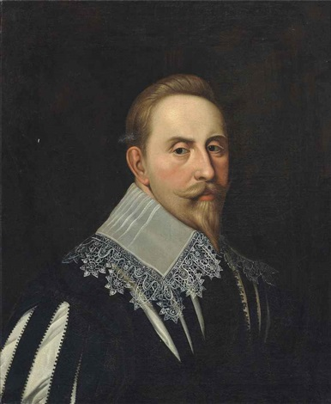
A vigorous monarch, and a military genius, Gustavus made peace with the Danes, and war upon the Poles. Sweden then intervened in the Thirty Years’ War which had been raging in Germany. The Holy Roman Emperor was determined to eradicate the Protestant Reformation in northern Germany through military conquest. Gustavus brought the Swedish army to Germany, and in a series of battles defeated the forces of the Catholic League. However at the battle of Lutzen in 1632, his last victory, Gustavus was killed. He left as the heir to the throne, his 6 year old daughter, Christina.

Sweden at this time was a major European power, controlling what is now Finland, and much of the lands south of the Gulf of Finland. At this time, many European powers sought to establish colonies in America. Sweden was no exception. Queen Christina’s government hired Peter Minuit, a Dutchman, to assist it in planting a colony in America. Minuit had previously been involved in the Dutch colony of New Netherlands, purchasing the island of Manhattan from the Indians in 1626. He selected as the site of the new Swedish colony the “South River” (now known as the Delaware River). Located on the west side of the river, the new settlement was named Fort Christina. The first colonists arrived in 1638. However, the Swedish government had difficulty in convincing its citizens to travel to America.
Gustavus Adolphus

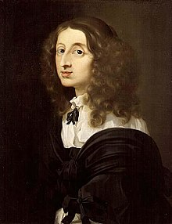
Queen Christina
Of Sweden

t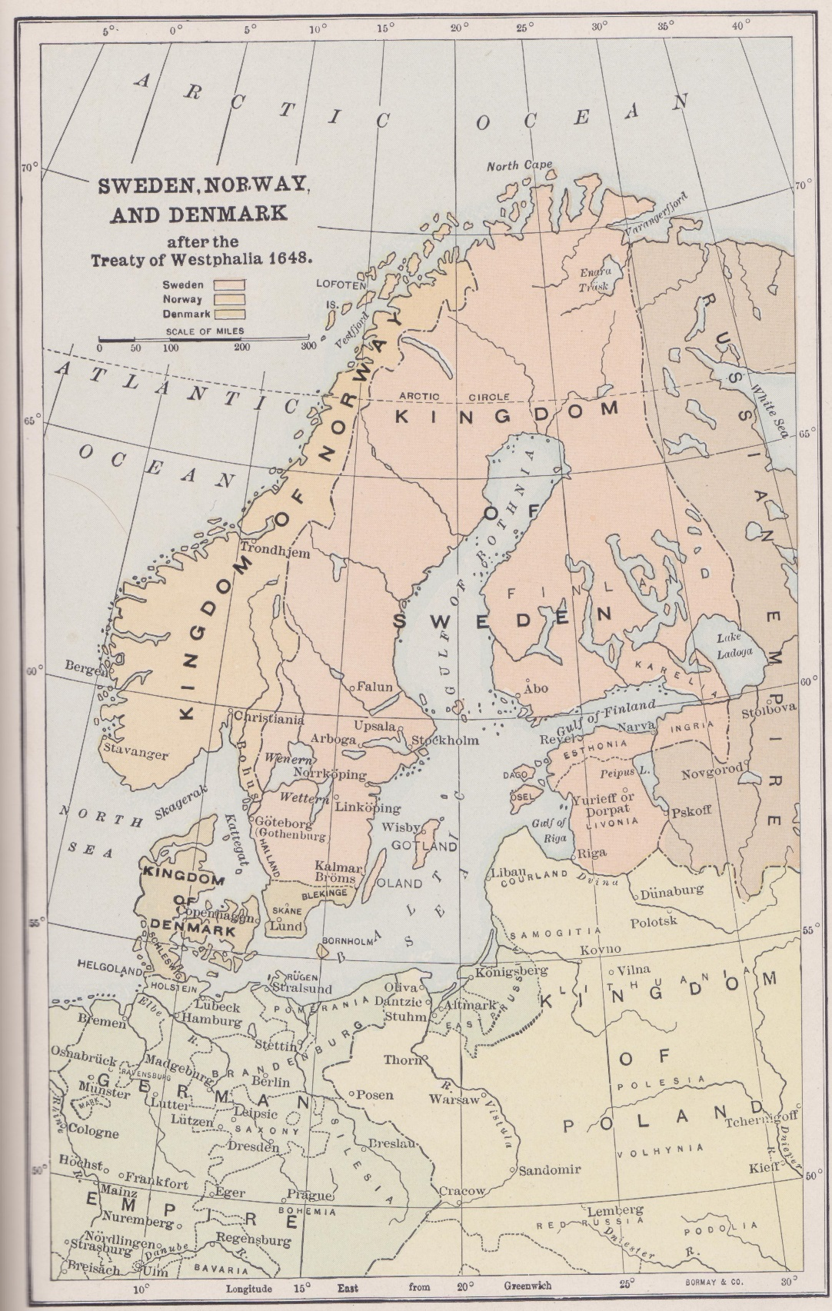
HANS MANSSON OF HANASKEDE
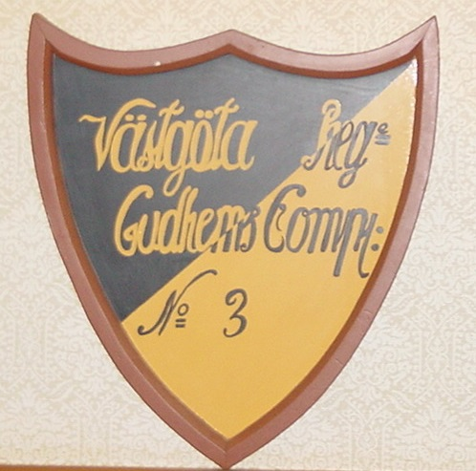
In 1684, Hans Mansson gave an affidavit to William Penn (founder of the colony of Pennsylvania) stating that he was 72 years of age. This places his year of birth in Sweden around 1612. In 1640, he was a cavalryman stationed at Hanaskede Manor, the homestead for horses for the Vastagota Rythare Reigment, outside of the town of Skara. Hans Mansson would have been in Gudhems Company 3. (see insignia of company to the right). One of his duties was to groom the horses. For this task, he needed combs, and best wood for this was from fruit trees. He found such trees at the abbey at Varnhem, which had been abandoned for a century.

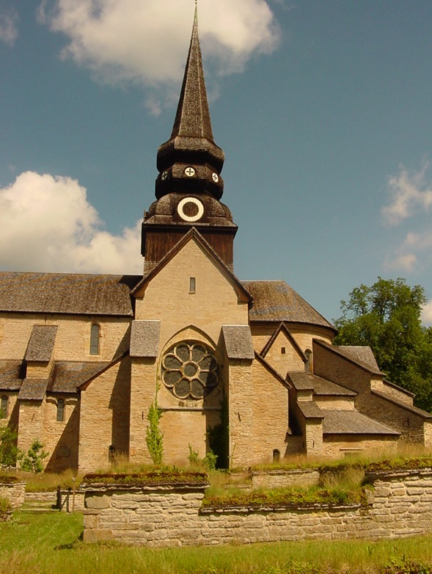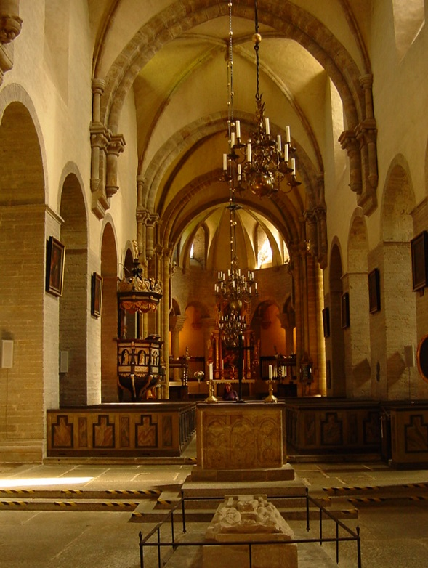
Varnhem Abbey as it appeared in 2002
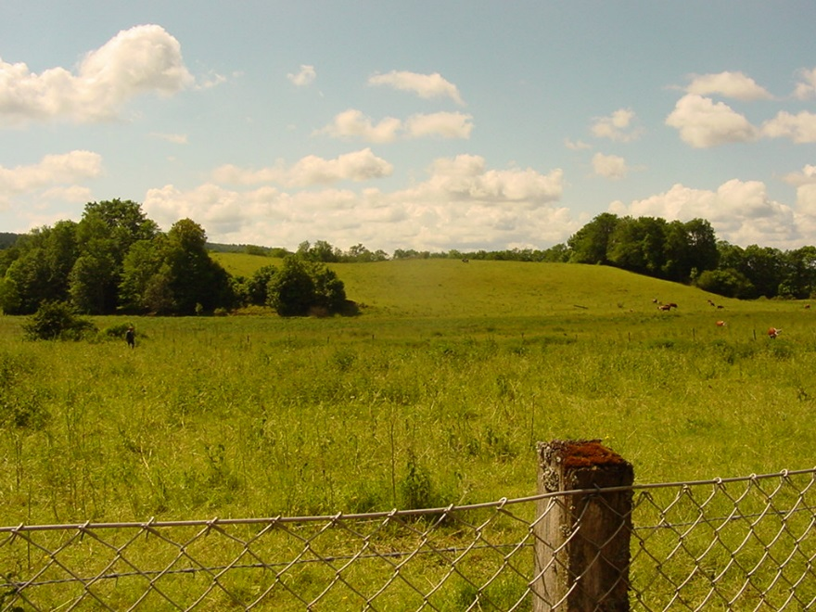
View of fields from the abandoned cloisters of Varnhem Abbey,
where Hans Mansson likely chopped down the fruit trees

In the fall of 1640, Hans Mansson was arrested at Hanaskede and charged with chopping down six apple trees and two cherry trees at Varnhem Abbey. This horrible crime was brought to the attention of Queen Christina and her council. In a letter dated April 13, 1641 to the Governor of Skaraborg Lan, the Queen stated:

“Inasmuch as we find this to be a much bigger and heinous crime than if he had broken into some man’s coffers and other property and there stolen some goods, for that reason Our Royal Pleasure and Command is that you shall bring him without delay to court to be condemned according to his crime, afterwards leaving to his discretion whether he should sail with wife and children on our ship from Gothenburg to New Sweden, or hang; if he chooses the voyage to the said New Sweden, then you could tell him that when he has been there for six years he will be pardoned. But if he does not, you may execute the sentence and let him hang according to his deserts; yet you must keep all this secret and not let him know those conditions before the sentence is passed.”

On May 31, 1641, in what was clearly nothing more than a show trial, Hans Mansson was found guilty by the court, and was sentenced to be hanged or go to New Sweden with his wife and family. The trial record states that “[h]e chose the voyage and was consequently imprisoned in order to be taken to Gothenburg.”

It should be noted that in the 1600’s the penalty for most crimes was either death or mutilation. While based upon our standards of justice, Hans Mansson was clearly mistreated by the Queen and the courts of Sweden, it is fortunate for the Steelman family that he chose the second option, and came to America.

Two ships, the Kalmar Nyckel and the Charitas set sail from Gothenburg, Sweden, and arrived at Fort Christina on November 7, 1641.

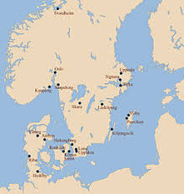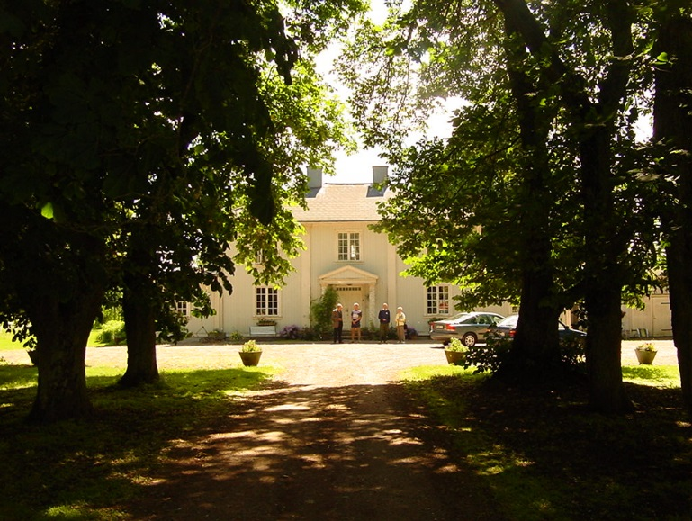
Map showing location of Skara, Sweden Hanaskede as it appeared in 2002
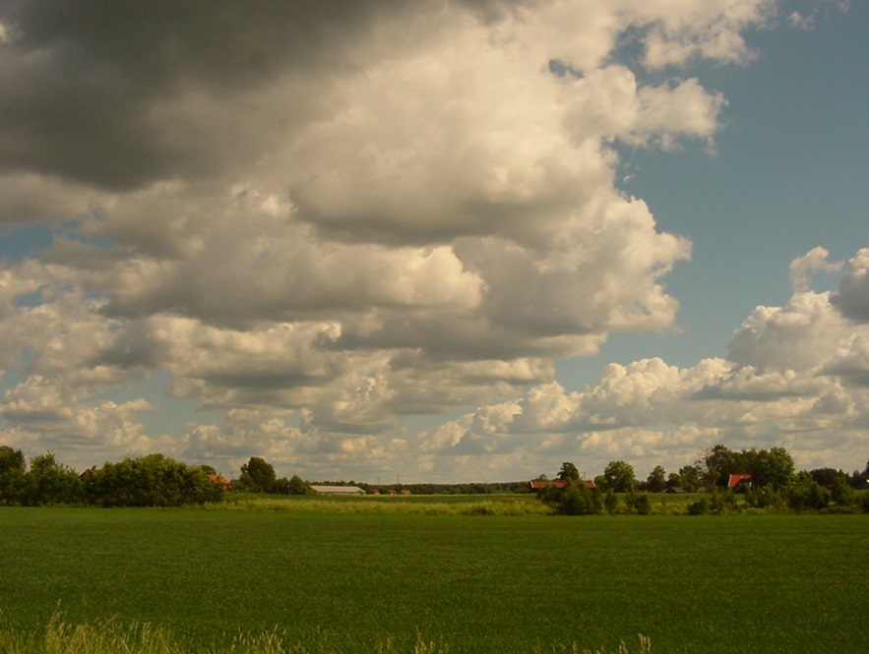
Countryside outside of Skara, Sweden
PHOTOGRAPHS OF A FULL-SCALE REPRODUCTION OF THE KALMAR NYCKEL, ONE OF THE SHIPS THAT SAILED FROM GOTHENBURG TO NEW SWEDEN IN 1641
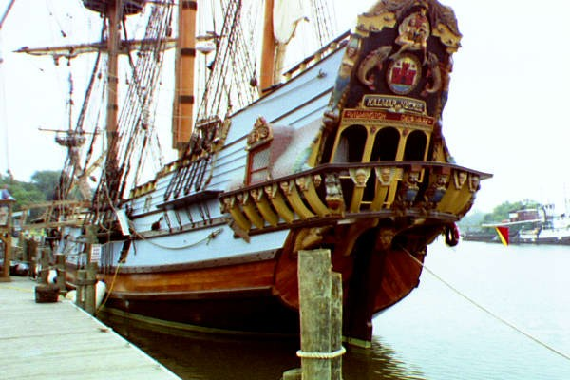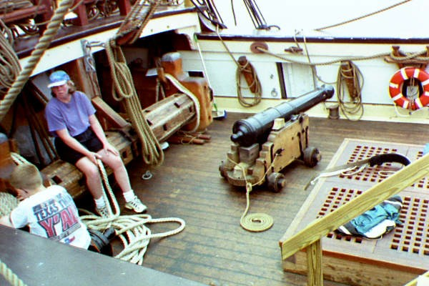

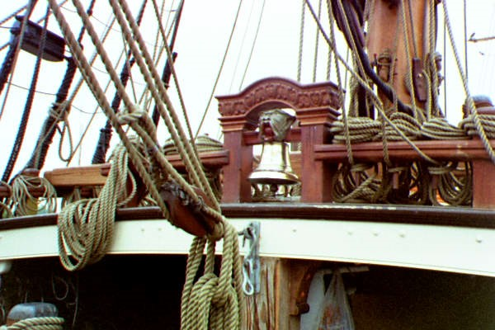
Photos from the formal dedication of the Kalmar
Nyckel, 1998, Wilmington, Delaware

Imagine crossing the Atlantic Ocean for many months on a ship this small.
MAP OF NEW SWEDEN
ON THE DELAWARE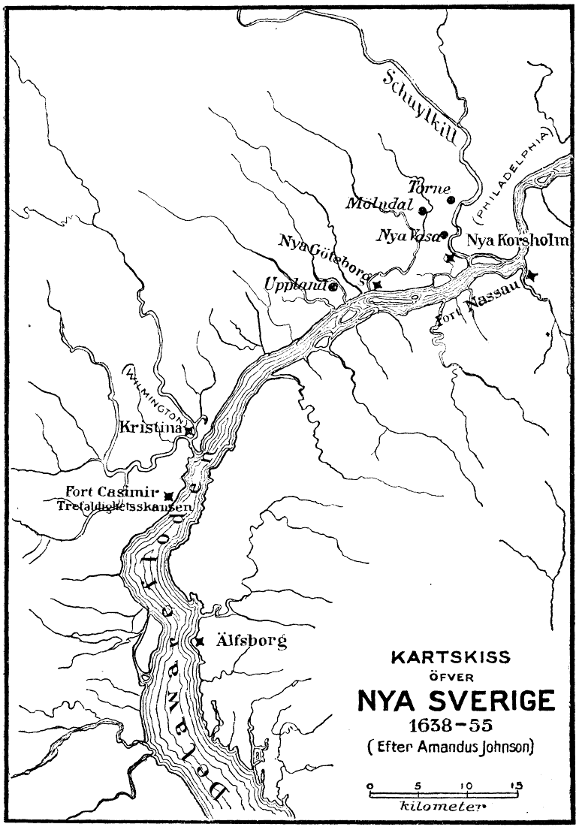

HANS MANSSON IN AMERICA
In 1644, Hans Mansson was a laborer planting tobacco at Upland. By 1648, having served his six-year sentence, he was a freeman living in the colony.

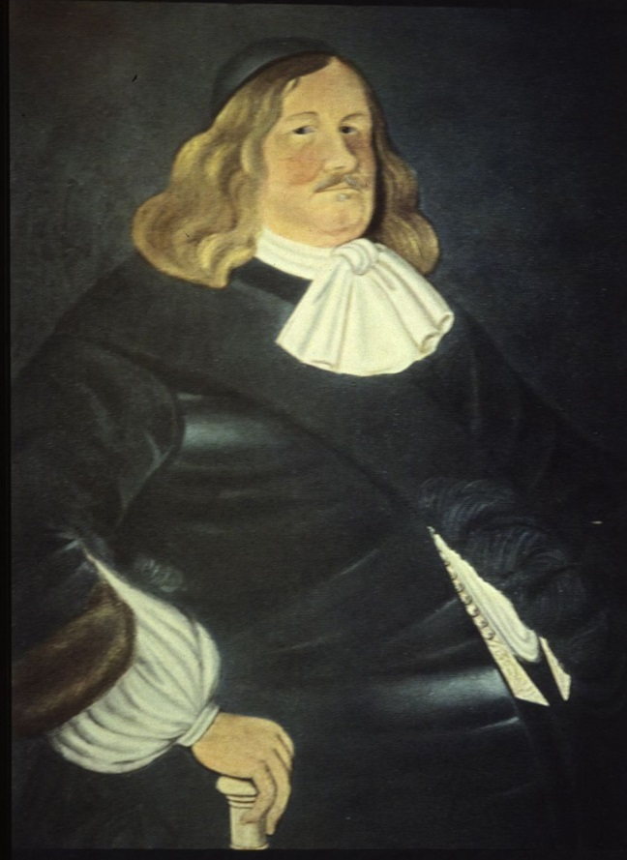
On February 15, 1643, two ships, the Fawn and the Swan arrived at Fort Christina, bearing the new governor of the colony of New Sweden, Johan Printz. Printz was a huge man, nearly seven feet tall and weighing over 400 pounds. He was referred to as “Big Belly” by the Indians. At the ceremonies marking the 300th Anniversary of the founding of New Sweden in 1938, President Franklin D. Roosevelt quipped:

“There never was a Governor, before or since,
that weighed as much as Johan Printz.”

Unfortunately for the colonists, Printz was not a jolly old soul, but an autocratic administrator. On July 27, 1653, Hans Mansson was one of 22 settlers who signed a petition protesting Printz’ oppressive rule. Printz promptly had the ringleader of the protestors, Anders Jonsson hung on August 1, 1653. Shortly thereafter, Printz was recalled to Sweden, and left the colony in 1654. The last governor of New Sweden was Johan Rising, who was to make extensive use of Hans Mansson in 1654 and 1655.
On June 7, 1654, Hans was sent by Governor Rising to Maryland to try and convince deserters from New Sweden to return to the colony. He returned on June 15, 1654, having no success, but advised that a delegation of Maryland officials was en route.
The Dutch in New Amsterdam (now New York City) were never happy with a Swedish colony on the “South River”. They were viewed as competitors for the lucrative Indian trade. In July, word came from New Amsterdam that Governor Rising’s emissary to the Dutch, Peter Jochim, had died. Peter was a German soldier and friend of Hans Mansson. He was married to Ella Stille, and had a son, also named Peter Jochim. Hans volunteered to go to New Amsterdam on July 27, 1654 and determine what the Dutch were up to. He returned on August 12, 1654, reporting that Dutch Governor Peter Stuyvesant was awaiting orders to come to the South River, and clear out the Swedes.
The relations between the Swedes and the Dutch continued to deteriorate, in part because Governor Rising had ejected the Dutch from New Sweden, and seized a Dutch fort located on the east bank of the South River. In August of 1655, Governor Rising sent Hans Mansson and Jacob Sprint to Staten Island to spy upon the Dutch. They returned with information that Stuyvesant was preparing to invade the South River with a flotilla of ships and many soldiers. On August 31, 1655, Hans volunteered to go to the defense of Fort Christina. Faced with overwhelming military force, and knowing that no help would come from Sweden, Governor Rising surrendered the Swedish forts along the South River to the Dutch. New Sweden was formally incorporated into New Netherland on September 15, 1655. The Swedish settlers were allowed considerable local autonomy, retaining their own militia, religion, courts, and lands. Dutch rule only lasted for 9 years. By October 1664, both New Netherland and the forts on the South River were captured by the English. The lands that had been New Sweden became part of the English colonies of Pennsylvania and Delaware.
Hans Mansson’s life changed dramatically in 1654, when he married Ella Stille, the widow of Peter Jochim. He moved to Aronameck plantation, where the Jochims had lived, on the south bank of the Schuylkill River. On May 14, 1669, Hans Mansson received a patent for several tracts of land, including Aronameck, which was estimated to contain 100 acres. When the property was eventually surveyed in 1675, it was found to contain 1100 acres. Quite a discrepancy!
It is my belief that Aronameck belonged to the Jochim family, and when Peter Peterson Jochim came of age, the property was conveyed to him. Aronameck was subsequently acquired by botanist William Bartram in the late 1700’s. The site of Hans Mansson’s home is now part of Bartram Gardens in South Philadelphia. This is a beautiful 45 acre preserve located on the south bank of the Schuylkill River. Portions of the house may date to the time of Hans Mansson.

PHOTOS OF BARTAM’S GARDEN
(ARONAMECK PLANTATION)
PHILADELPHIA, PA

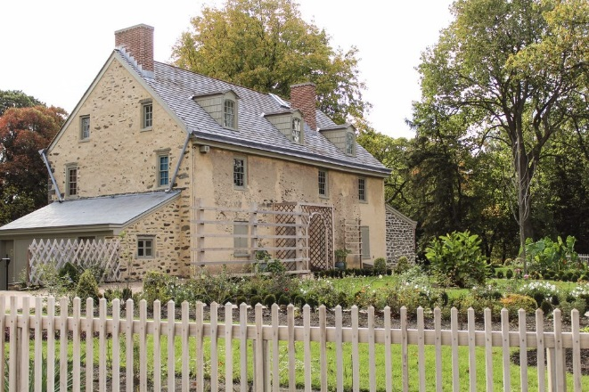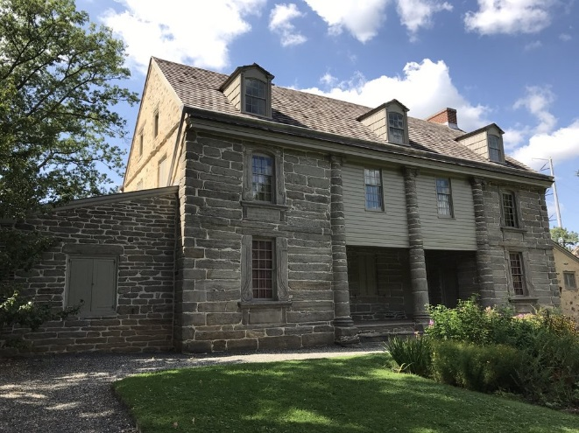

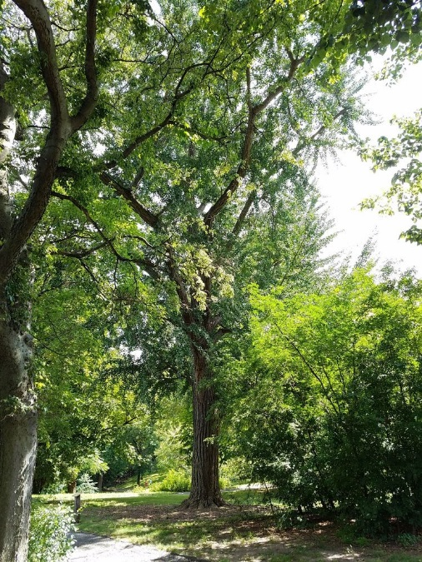
In 1672, Hans Mansson became captain, and commanding officer, of the militia. As a central place of defense, a blockhouse was built at Wicaco which also served as the Lutheran Church for the up-river Swedes from 1677 until construction of Gloria Dei Church in 1700. Wicaco was the Indian name of the settlement north of the Schuylkill River. From that point forward, he was known as Captain Hans Mansson. We know that settlement today by the name given to it by William Penn; Philadelphia. When Penn arrived in America in 1682, Hans Mansson and the Swedes had been there for 40 years! We know from a letter written by William Penn to Hans’ son, John Hanson Steelman, that Penn knew Hans Mansson.
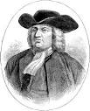
William Penn
THE MOVE ACROSS THE DELAWARE TO NEW JERSEY
In February, 1674, Hans Mansson obtained a permit to settle land across the Delaware River in West Jersey. At that time, New Jersey was divided into two colonies, East Jersey and West Jersey. It does not appear that Hans immediately moved across the river, but waited several years before moving his entire family (other than Peter Jochim) to the east side of the river. He continued to serve as militia Captain. On November 13, 1677, Hans Mansson, along with Peter Jochim and Jan Stille petitioned the Upland Court that a town be formed on the west side of the river, below the falls. It is not clear whether they were referring to the Delaware River or the Schuylkill River. On November 12, 1678, the Upland Court found that it was necessary for a mill to be built on the Schuylkill River, and that there was “no fitter place” than the fall called Captain Hans Mansson’s fall. Captain Hans agreed to the construction of the mill. This would support the conclusion that the 1677 request was for a town on the Schuylkill River.
The records of the court at Burlington, West Jersey on August 3, 1680, show Captain Hans Mansson to be a freeholder. On April 29, 1681, Hans Mansson deeded to Peter Jochim the 1100 acre tract on the west side of the Schuylkill River (Aronameck Plantation). Thus, by 1680-81, we can assume that Hans and his family had moved across the river. On August 24, 1682, 500 acres in New Jersey were surveyed for Hans Mansson and Frederick Frederickson, next to the river. The deed for this property was recorded on February 12, 1684. On April 10, 1688, Hans Mansson, described as a planter of Senamensinck, Burlington County, received a patent for 100 acres from William Biddle.
On May 10, 1692 the Widow Hance was shown in the town meeting book for Chester Township, Burlington County, New Jersey, rated for taxes. This would indicate that Captain Hans Mansson died over the winter of 1691-2.
Andreas Rudman was the pastor of Gloria Dei Church in Philadelphia (Old Swedes Church) from 1697 to 1708. In 1697, he prepared a list of the parishioners of Gloria Dei Church, which included members on the east side of the Delaware River. Included in this list is the following entry: "Mrs. Ella, mother of the Steelmans now. Her sons: Eric, aged 16 ys.; Charles, 18 ys." This is the first known usage of the name Steelman in the records of the Delaware Valley. The word “now” indicates that there has been a change in the name of the family. The entry referred to “Mrs. Ella” who was Ella Stille who married Hans Mansson, and to their two youngest sons, Eric and Charles.
A deed recorded in Deed Book DD at page 206 of Burlington County, New Jersey provides clear confirmation that Hans Mansson was the father of the Steelmans:
"A deed made 25 May 1730 by Charles Steelman of the County of New Castle on Delaware, son and heir of Charles Steelman, late of Sinsminson, Burlington County, New Jersey deceased, by and with advice and consent of John Bird of New Castle and Margaret, his wife, and of David Enuxen and Eleanor his wife of the same County, sisters of the aforesaid Charles Steelman, sells to Philip Waller of Evesham in Burlington County for £ 30.00 a small tract of land in Chester Township on the east side of Peniscukin Creek. The land was purchased of William Biddle by Hance Monsier, grandfather of the said Charles Steelman, by deed of 10 April 1688 and sometime after, was bequeathed by Hance Monsier to Charles Steelman, father of the grantor, Party to this Present, by the last will and testament of ye P. Haunce Monsiere, as will be ye Present will, recourse being etc."

Unfortunately, the will referenced in this deed has never been found. What a treasure that would be! Note that the name Mansson is found in many variant spellings in the records of New Sweden, Pennsylvania and New Jersey.

The widow of Hans Mansson, Ella Stille, was buried at the “Old Swedes” Church in Swedesboro, Gloucester County, New Jersey on January 22, 1718. There are no marked graves in the oldest sections of the cemetery. It is likely that Hans Mansson was also buried there.

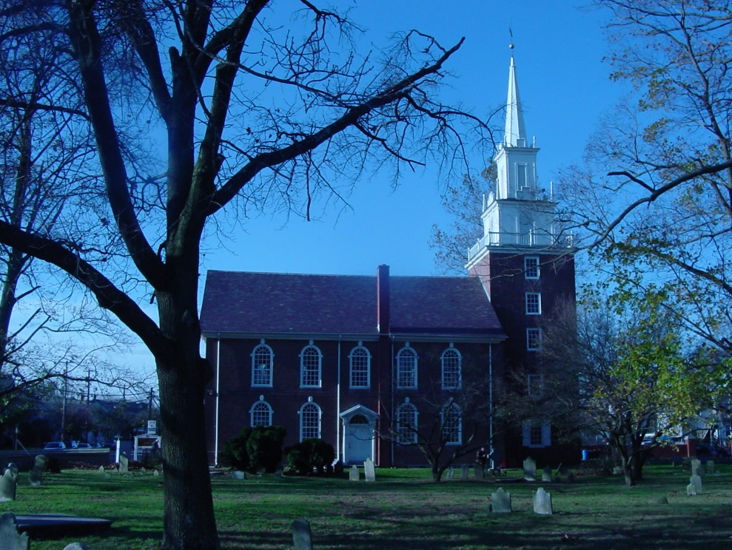
Old Swedes Church, Swedesboro, New Jersey

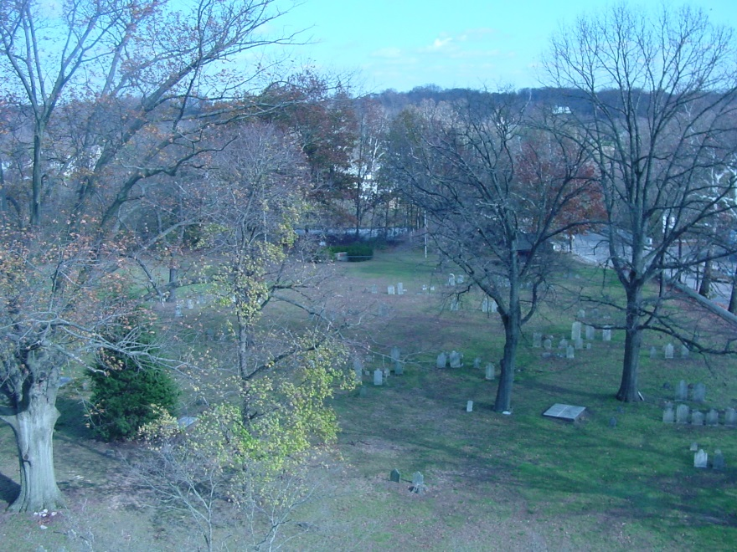
Graveyard of Old Swedes Church,
Swedesboro, New Jersey
Descendants of Hans Mansson

Hans Mansson (born ca 1612, Skaraborg County, Sweden, died ca 1691, Pennsauken Creek, Cinnaminson Township, Burlington County, New Jersey). He married (1st) _________ in Sweden, and (2nd) Ella Stille (widow of Peter Jochim) (born 1634, probably on the island of Humlo, Sweden, died 1718, Pennsauken Creek, Cinnaminson Township, Burlington County, New Jersey) ca 1654 in New Sweden.
Child of the First Marriage:

1. Mans Hansson.

Children of the Second Marriage:

2. John Hansson Steelman (born ca 1655 at Aronameck Plantation,
New Sweden, died 1749, Lancaster County, Pennsylvania) married Mary Stalcop.
3. James Hansson Steelman (born ca 1665 at Aronameck Plantation, died 1734, Gloucester County, New Jersey) married (1st) Susannah Toy, and (2d) Catherine Ouster.
4. Peter Hansson Steelman (born ca 1667 at Aronameck Plantation, died 1740, Gloucester County, New Jersey) married Gertrude Keen.
5. Christiern Steelman (born ca 1670) at Aronameck Plantation, died after 1739, probably New Castle County, Delaware married Mary Peterson.
6. Charles Hansson Steelman (born ca 1679 at Aronameck Plantation, died 1707, Cinnaminson Township, Burlington County, New Jersey) married Anna Nilsson ca 1700.
7. Eric Hansson Steelman (born ca 1681, Cinnaminson Township, Burlington County, New Jersey, died May 10, 1731) married Bridget ________.

According to Dr. Peter S. Craig (a descendant of Peter Jochim and Ella
Stille), Ella Stille, widow of Hans Mansson, and Hans’ sons by her adopted
the name of Steelman (Stille + Mans).
SOURCES OF INFORMATION
ON THE EARLY STEELMAN FAMILY

1. Adams, Arthur, Notes on the Steelman Family of Cinnaminson Township in Burlington County and Greenwich Township in Gloucester County, New Jersey, Pennsylvania Magazine of History and Biography, Volume 36 (1912), pp 464-472.

2. Adams, Arthur, The Steelman Family, Atlantic County Historical Society, Volume 3, No. 1 (1956) pp 51-69.

3. Catoni, Mac, Hanaskede Ryttare, (1997). (Historical Novel, book written in Swedish).

4. Cook, Ross, Hans Mansson and the Steelman Family, manuscript located at the American Swedish Historical Museum in Philadelphia, Pennsylvania, dated 1936.

5. Cook, Ross and Adams, Arthur, Captain Hans Mansson, Ancestor of the Steelman Family, The New York Genealogical and Biographical Record, Volume LXXIX, no. 3 (1948), pp 112-121.

6. Craig, Peter Stebbins and Yocum, Henry Wesley, The Yocums of Aronameck in Philadelphia, 1648-1702, National Genealogical Society Quarterly, Volume 71, Number 4 (1983) pp 243-279.

7. Craig, Peter Stebbins, The Stille Family in America 1641-1772, Swedish American Genealogist, Volume VI, Nos. 3 and 4 (1986) pp 141-176.

8. Craig, Peter Stebbins, 1671 Census of the Delaware, Genealogical Society of Pennsylvania, Philadelphia, Pennsylvania (1999) pp 18-19.

9. Federal Writers’ Project of the Works Progress Administration, State of New Jersey, The Records of the Swedish Lutheran Churches at Raccoon and Penns Neck, 1713-1786, The New Jersey Commission to Commemorate the 300th Anniversary of the Settlement by the Swedes and Finns on the Delaware (1938), Reprinted by The Gloucester County Historical Society, Woodbury, New Jersey (1982).

10. Gehrig, Charles T., Ed., New York Historical Manuscripts: Dutch Vol XX-XXI, Delaware Papers, 1664-1682, Baltimore (1977) p.201.

11. Jameson, J. Franklin, Ed., Narratives of Early Pennsylvania, Western New Jersey & Delaware, 1630-1707, New York (1912).

12. Johnson, Amandus, The Swedish Settlements on the Delaware, 1638-1664, Volume I, Philadelphia Swedish Colonial Society (1911) pp 462-463.

13. Johnson, Amandus, The Swedish Settlements on the Delaware, 1638-1664, Volume II, Philadelphia Swedish Colonial Society (1911) Appendix B, p. 712.

14. Myers, Albert Cook, Ed., Walter Wharton's Land Survey Register 1675-1679, The Historical Society of Delaware, Wilmington, Delaware (1955), pp 69-71.

15. Nelson, William, Ed. Documents Relating to the Colonial History of the State of New Jersey, Volume XXI, Genealogical Pulishing Co., Inc., Baltimore, Maryland (1976), p. 352.

16. Steelman, Harold M., Descendants of Matthias & Ruth Steelman of Surry County, North Carolina, privately published manuscript, located at the North Carolina State Archives, Raleigh, North Carolina.

17. Robert B. Steelman and James F. Steelman, A Riddle Revolved, Hans Mansson was the Swedish Trooper in 1641, Bulletin of the Gloucester County Historical Society, Vol. 22, No. 8., (June, 1991).

18. Steelman, William D., A Revisit to Hans Mansson, The Swedish Trooper in 1641, Bulletin of the Gloucester County Historical Society, Vol. 25, No. 4., (June, 1996).

19. Steelman, William D., Hans Mansson’s Parents?, Bulletin of the Gloucester County Historical Society, Vol. 25, No. 7., (March, 1997).

20. The Pennsylvania Magazine of History and Biography, Volume II, p. 342 (1878).

21. "The Missing Evidence: Two Depositions by Early Swedish Settlers" The Pennsylvania Magazine of History and Biography, Volume 91 (1967), p. 37.

The Mark of Captain Hans Mansson
From Affidavit given on June 25, 1684

